MCP101 Project Report

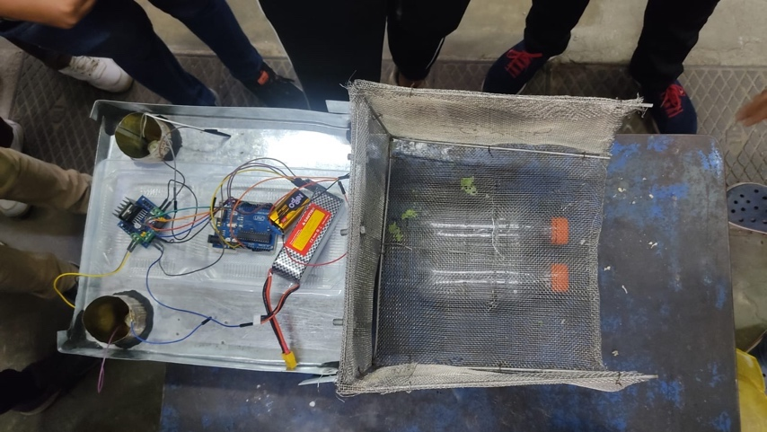Remote Controlled River Cleaning Vehicle

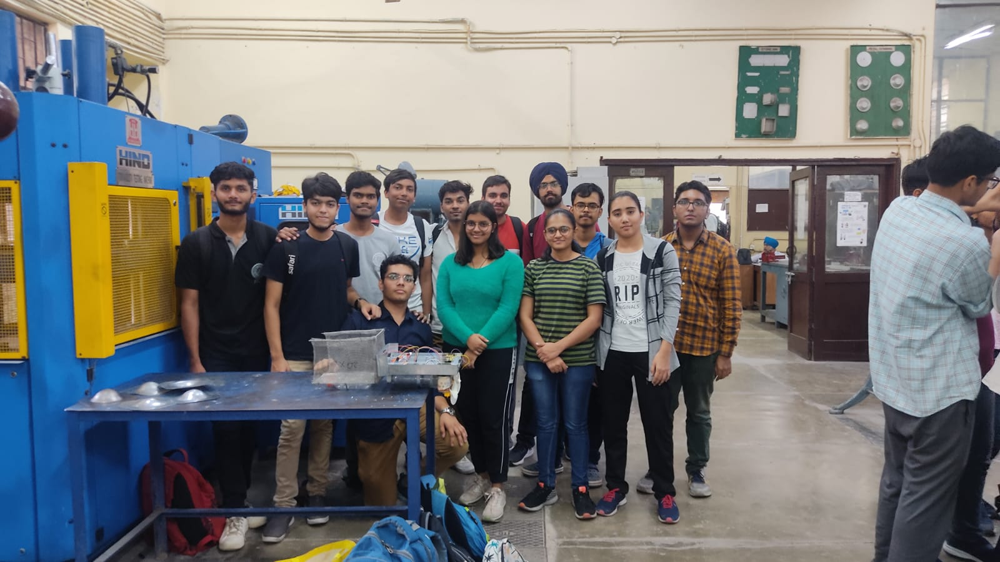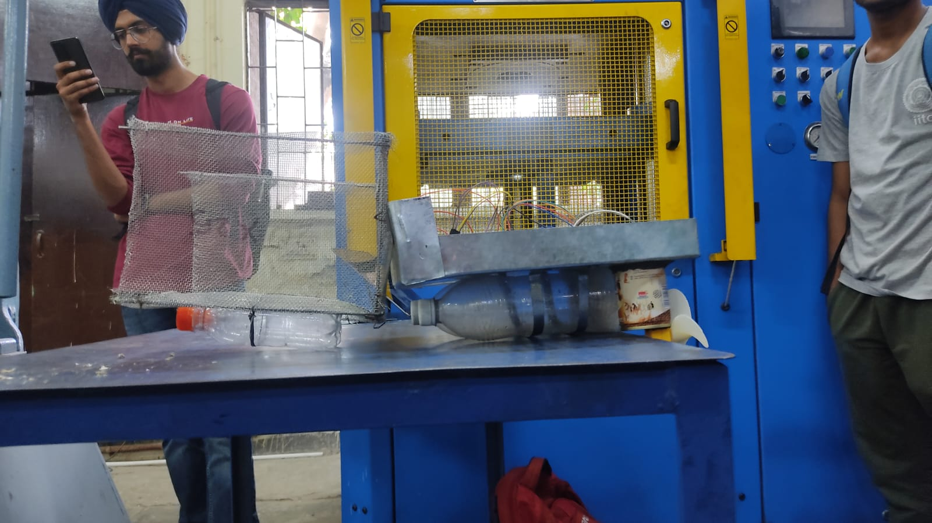

Index

|  |  |  |
| --- | --- | --- |
| Sl. No. | Title | Page No. |
| 1 | Introduction | 3 |
| 2 | Materials Used | 4 to 6 |
| 2 | Shops Used | 7 to 9 |
| 3 | Project Timeline | 10 to 13 |
| 4 | Problems Faced | 14 |
| 5 | Conclusion | 15 |
| 6 | Cost Estimation | 16 |
| 7 | Individual Contribution | 17 |

**Introduction**

As the name suggests, our project’s main aim is to clean the garbage from the surface of the water bodies. We have brought this to reality by assembling several distinct parts, most of which are hand-made, and some have been respectfully purchased from respective online and offline stores. We have even tried to make it economical by using several items from trash, such as, used coffee cans and soft drink bottles.

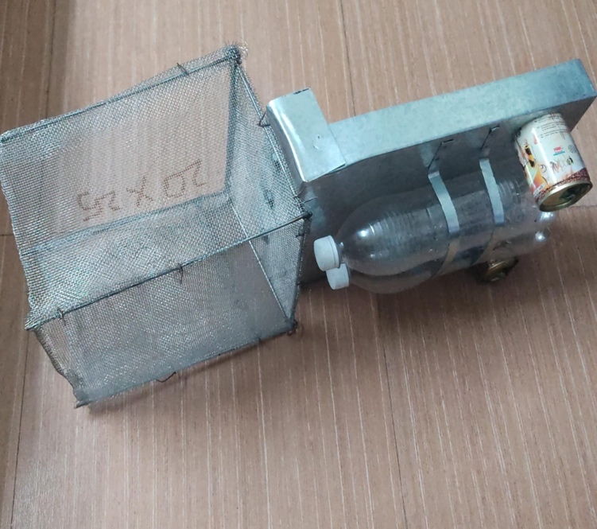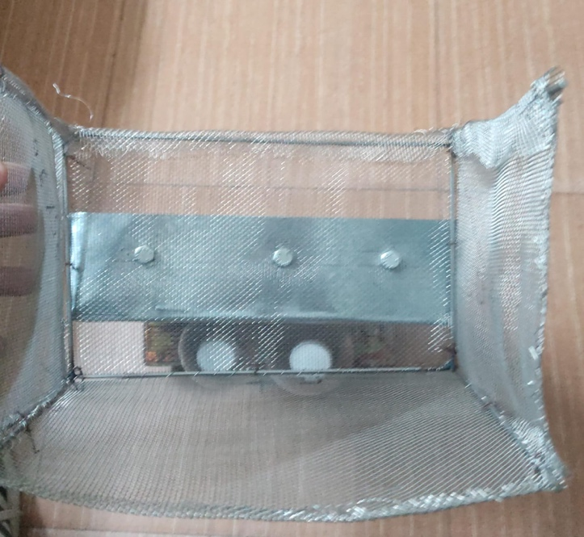The basic idea was to collect garbage from the surface, for which we have attached a net mesh in the front of a hydro-motorable vehicle, which is being driven by a pair of propellers, which are, in turn, powered by motor driver and Arduino circuit, having Bluetooth attached to it for the purpose of making it remote-controlled.

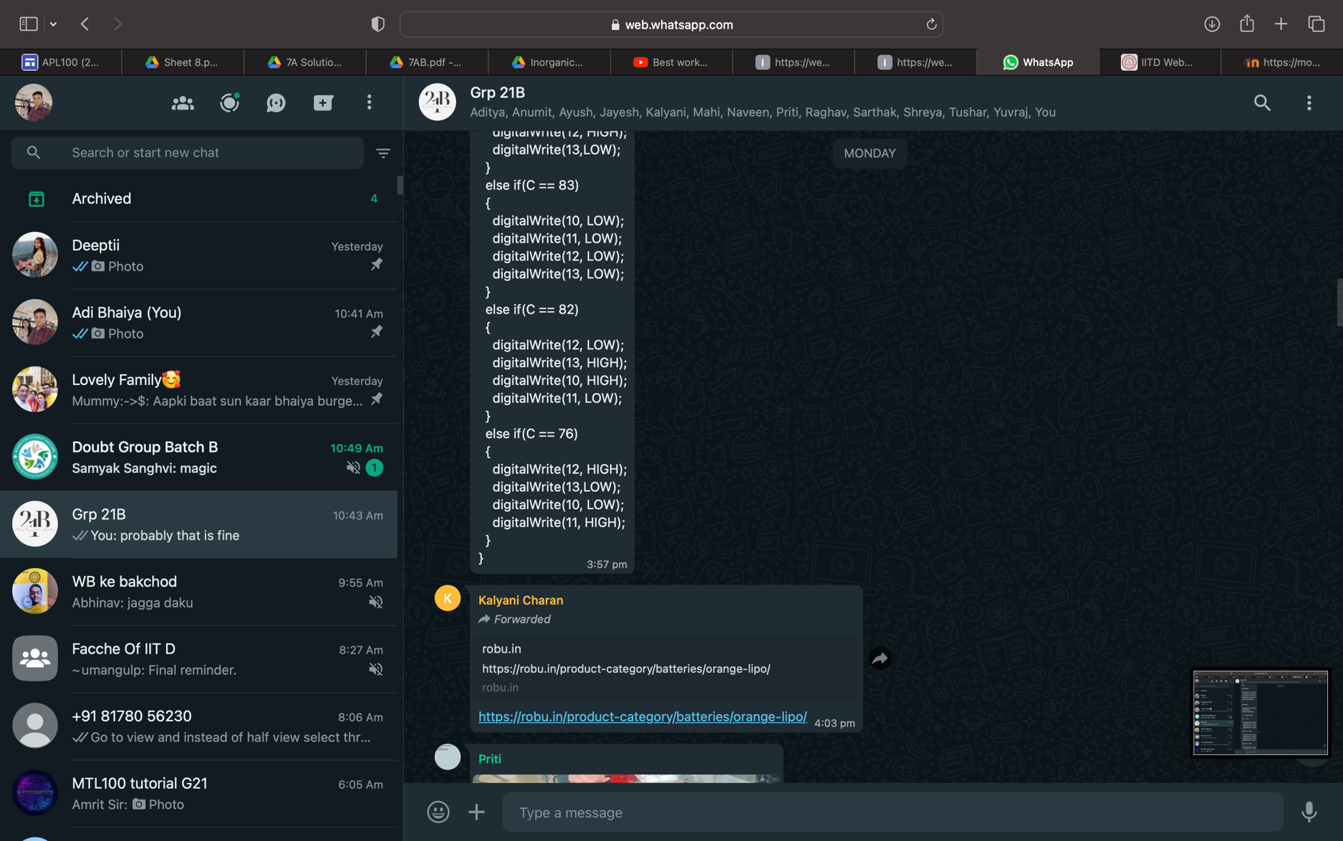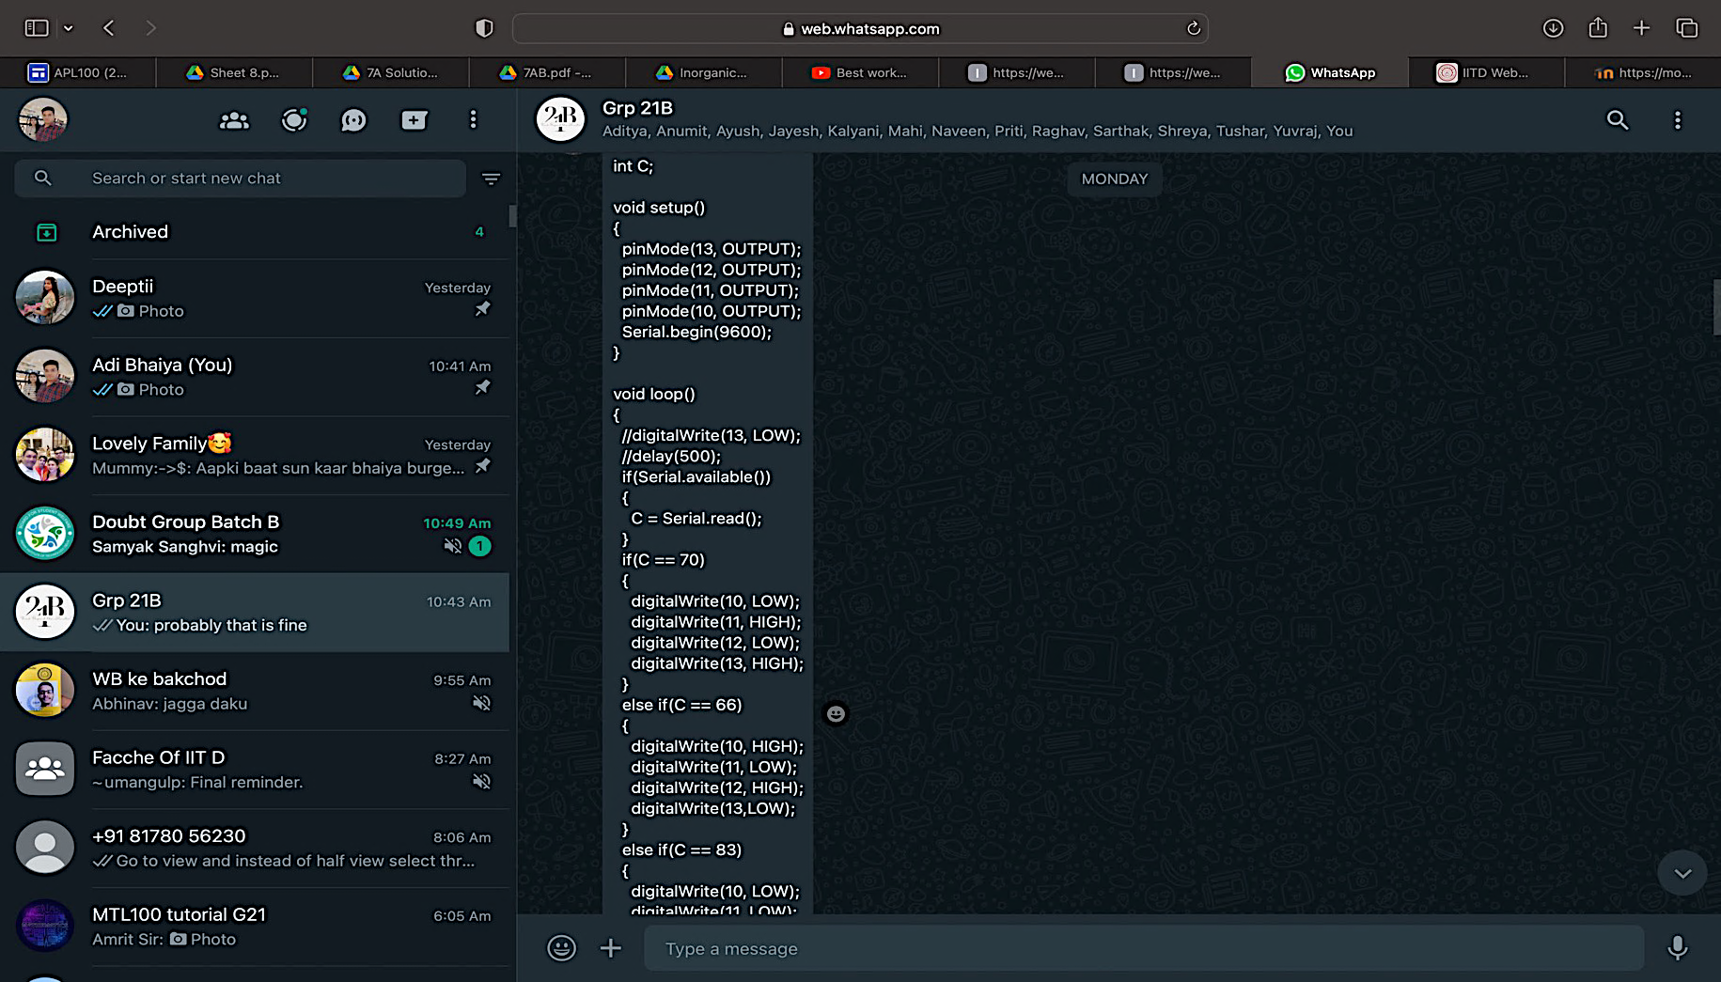

We have designed a code which would be run into an Arduino and controlled via Bluetooth from our phones. This code would help the motors, which are situated at the back side of the boat, work and help in maneuvering the system.

**Materials Used**

1. 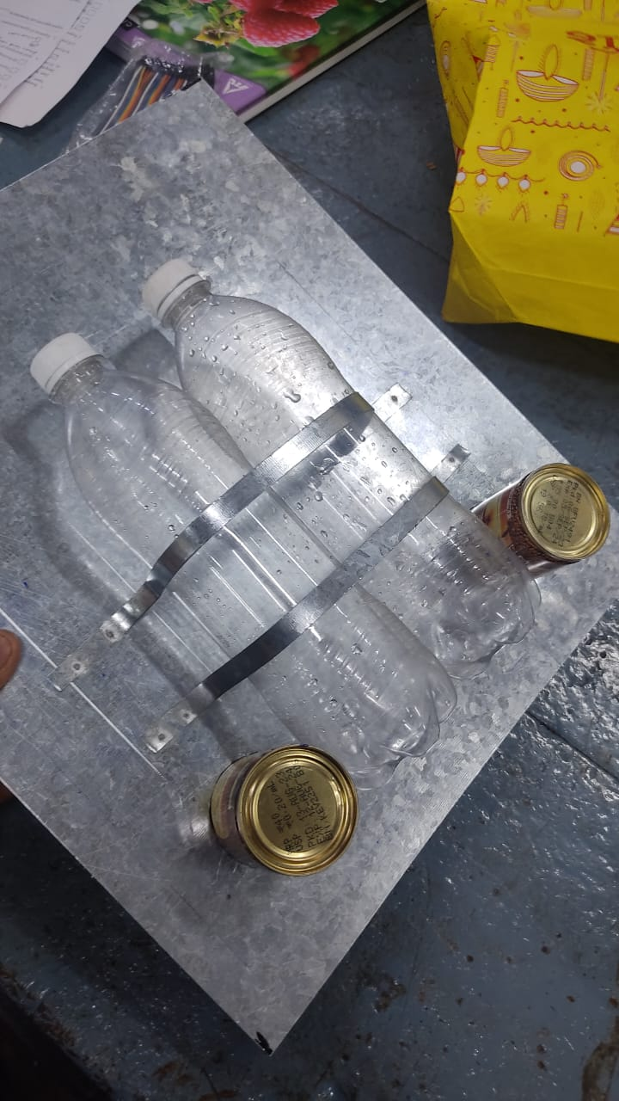Galvanized Iron (GI) Sheet (0.5 mm)

Galvanized Iron Sheet

Tin Coffee Can

750 mL bottles

Galvanized Iron Strip

1. 2 x Tin coffee can

Spot Welding

1. 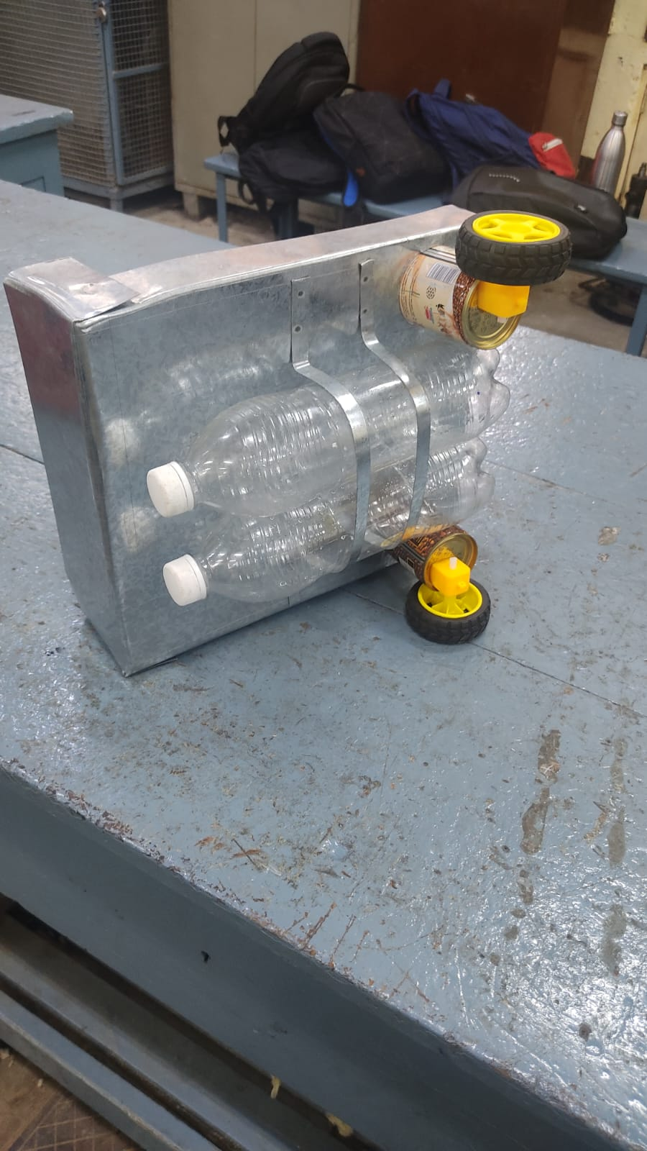2 x Motor

Denotes Propeller

Motor

1. 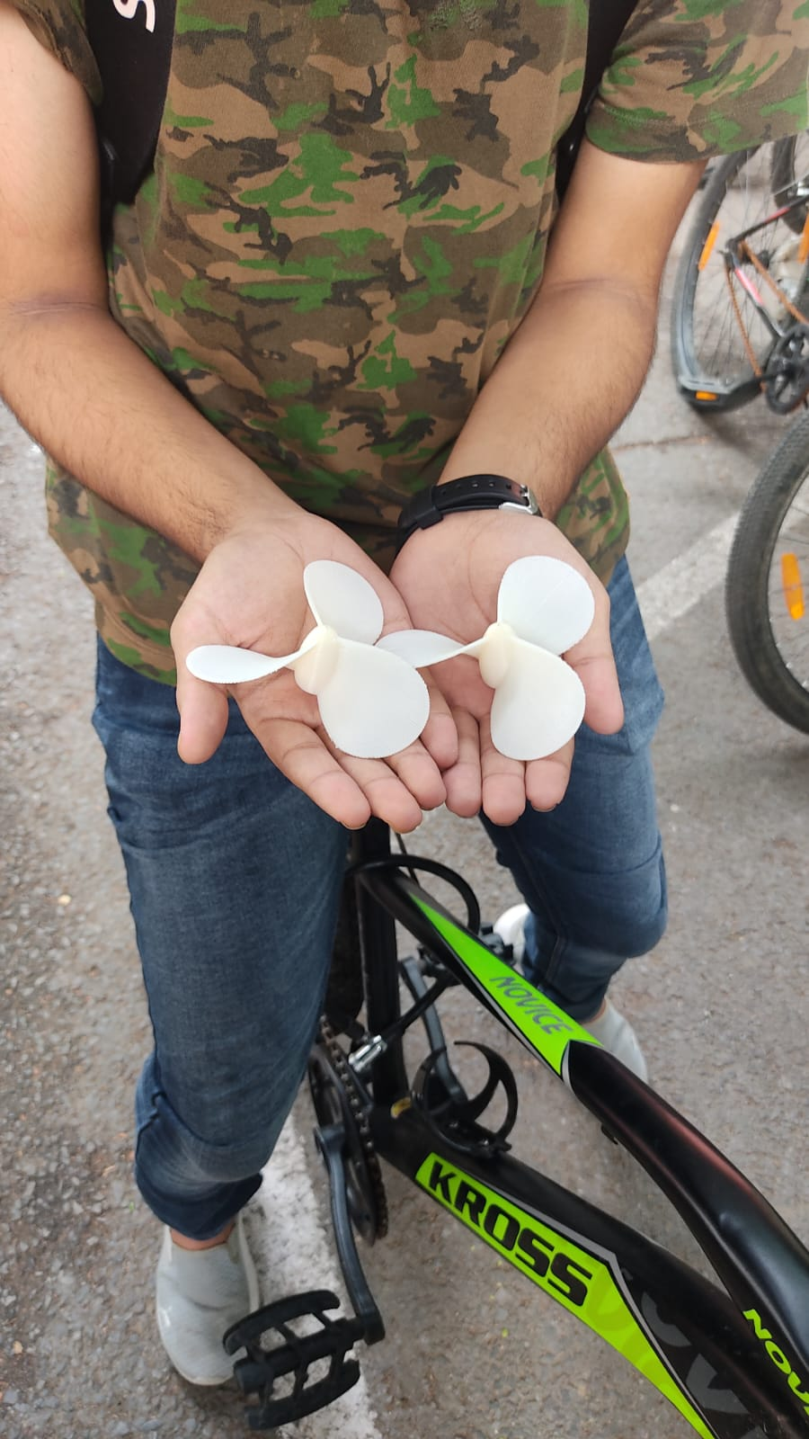2 x 3-D printed Propeller
2. 2 x 750 mL bottles
3. 2 x 250 mL bottles
4. Wire Mesh
5. 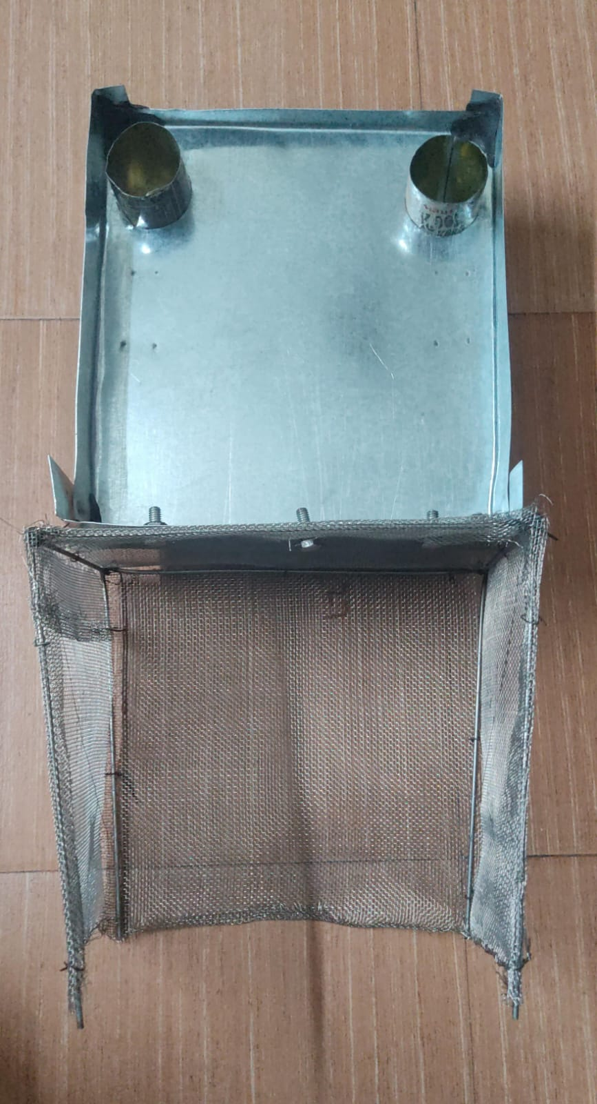Mild Steel rods for frame
6. Customized Bolts and Nuts
7. Galvanized Iron Strips
8. 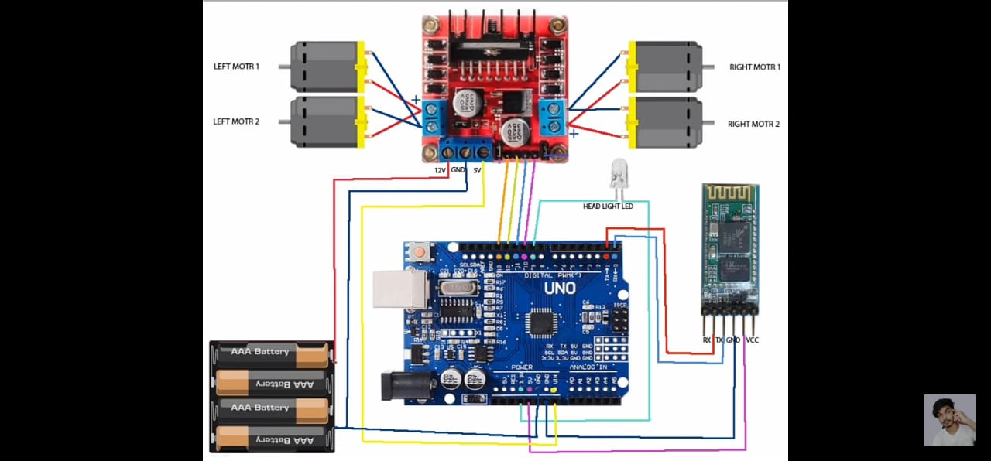Arduino circuit

Bluetooth

Module

Motors

Motor Driver

Battery

Arduino

Jumper wires

1. Jumper Wires
2. Motor Driver
3. LIPO 11.1 V Rechargeable Battery
4. 2 x Motor
5. M-Seal for water proofing
6. Fevikwik
7. Bluetooth module
8. Transparent Plastic Plate
9. 9V battery

Shops Used

Sheet Metal: It was used to acquire the GI sheet and to bend, cut and attain the most appropriate shape of the base. It was also used to acquire strips of required dimensions.

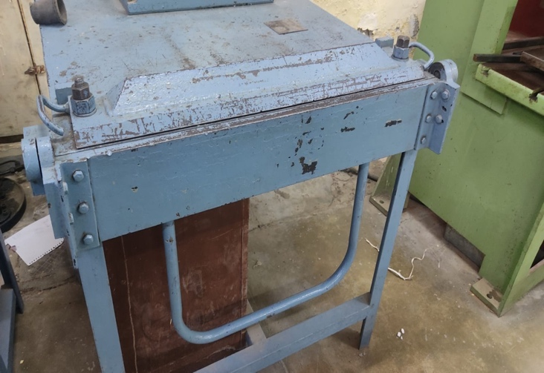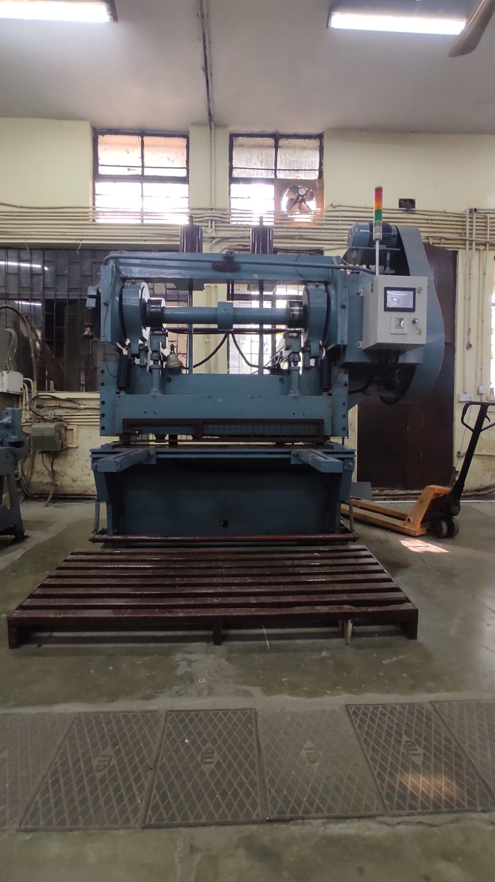

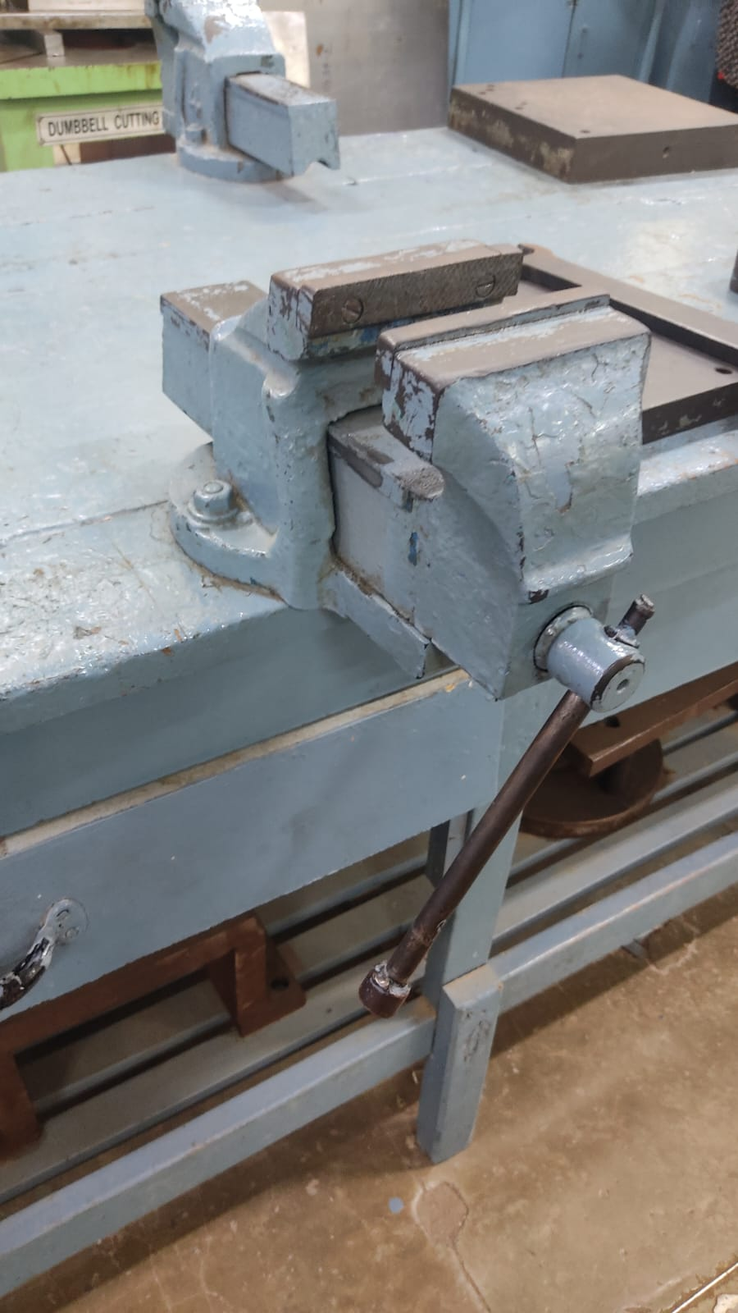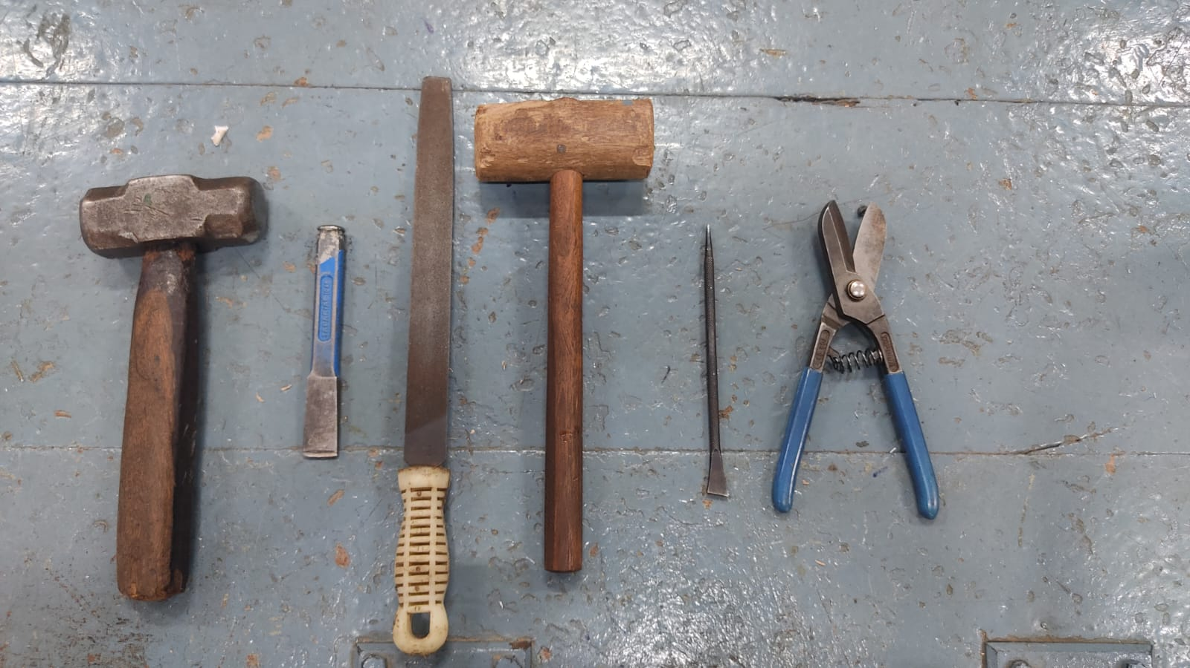

Fitting: It was used to make holes on the base to fit the cans, to cut the cans from the top, to cut the MS rods, to make the holes in the can to attach the motors at the bottom, to cut the nuts at the required length and filing the sharp edges after cutting.

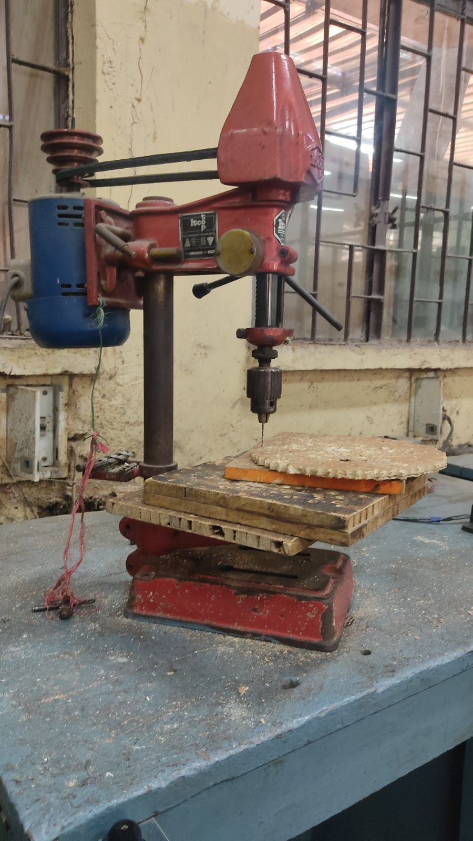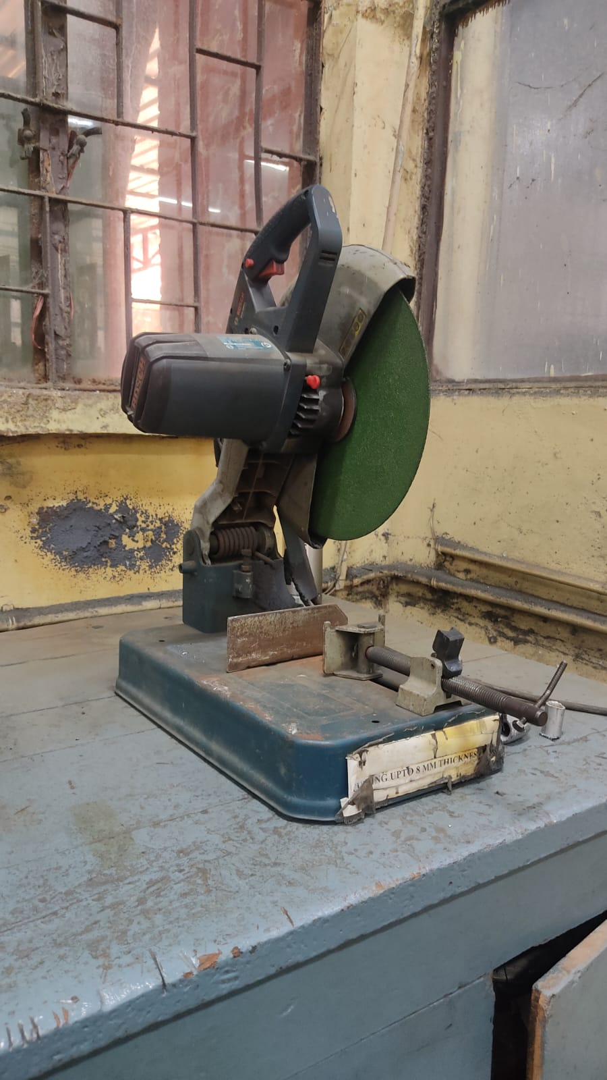

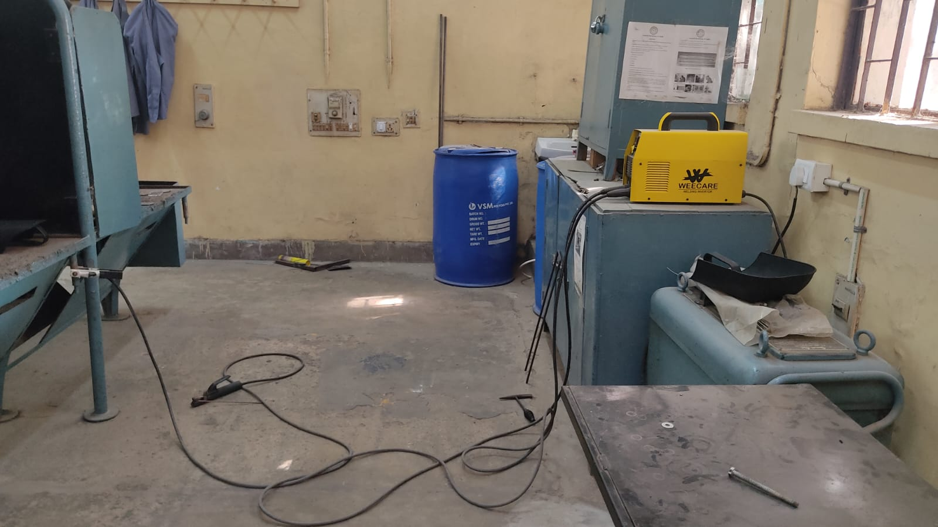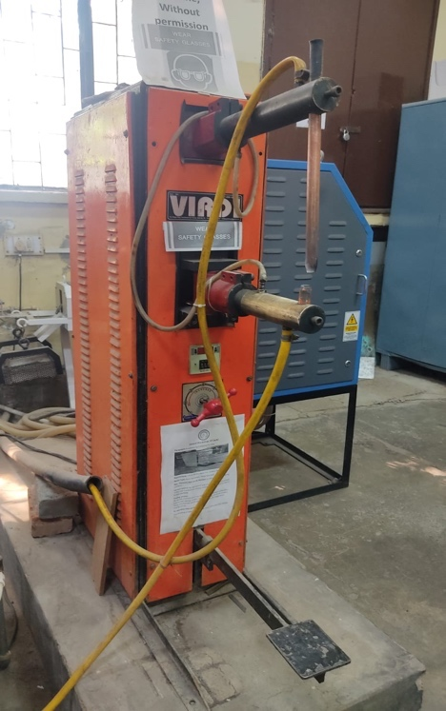Welding: Resistance spot welding was used to join the strips to the base for gripping the bottles and to seal the edges of the base. Shielded Metal Arc Welding (SMAW) was used to make the frame of the net.

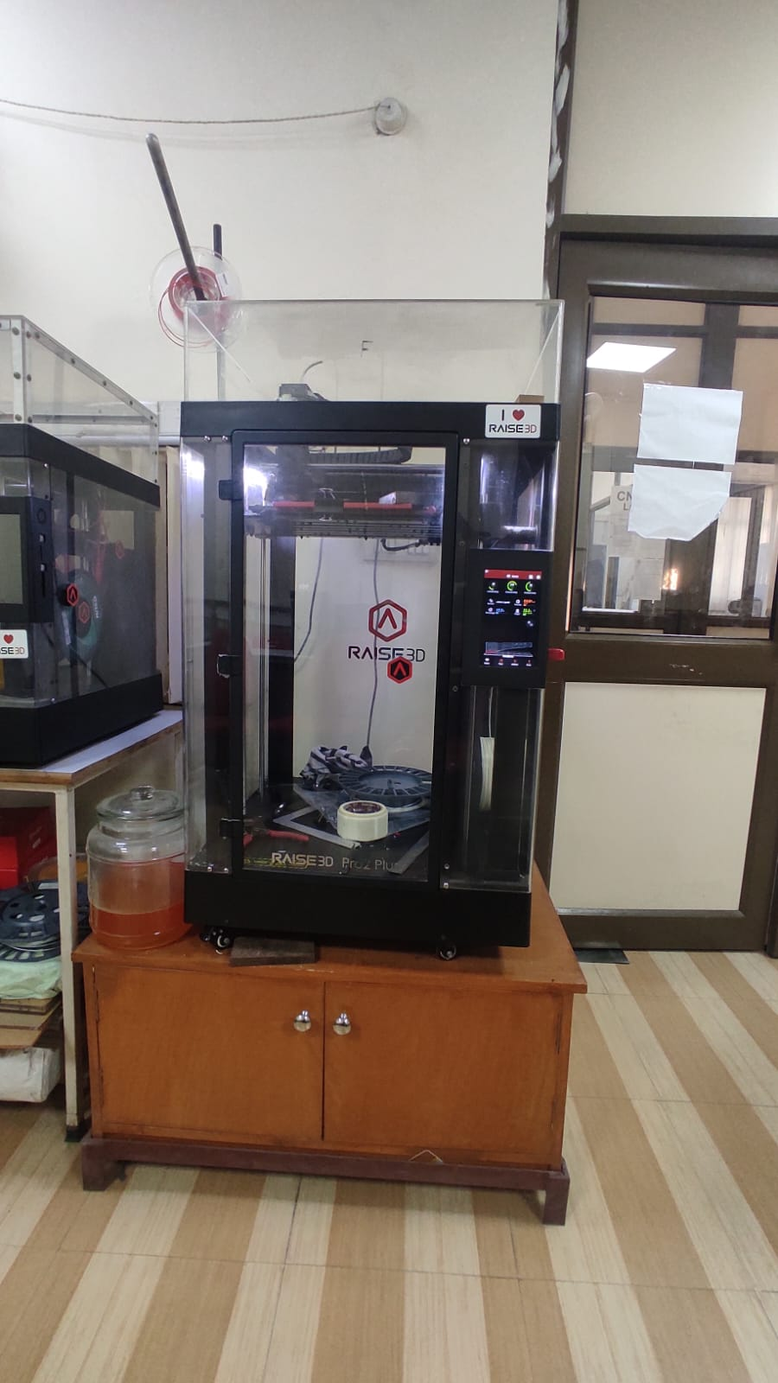Computer Numeric Control (CNC): It was used for printing the 3D model of the propellers.

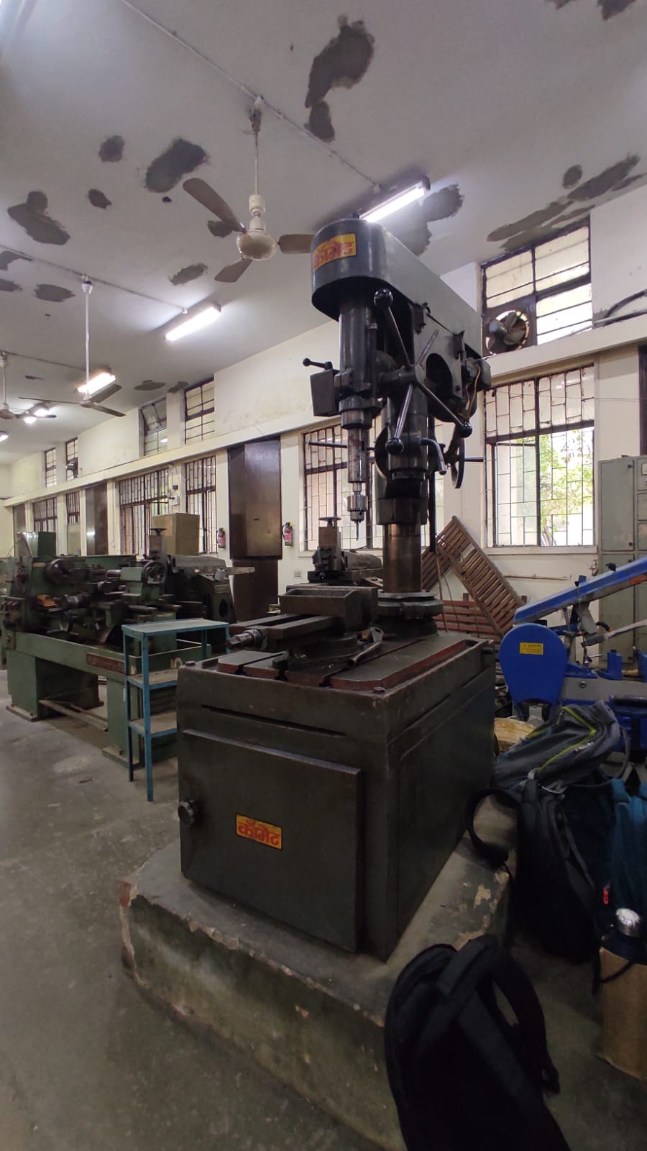Machining: It was used for making holes in the front of the boat to attach the net.

Project Timeline

Day 1:

* We had the idea in our hands, but we had to figure out how to collect the waste, either using iron mesh or conveyor belt.
* After thinking of all the pros and cons of the two mechanisms, we finalized the idea of having a net at the front.
* Then we started making a blueprint, estimating the dimensions, and filled our job form and got it signed.

Day 2:

* We got our metal sheet sanctioned and started cutting it as per the dimensions (38 x 35 cm).
* Then we proceeded for making the holes using Chisel and Hammer (R = 3cm) for the cans at the fitting workshop. We also filed the hole using File.
* Having done so, we also cut the cans 9 cm in length and attached them to the metal sheet. Here also, we performed filing.
* Finally, as our last task, we used Resistance Spot Welding to attach the bottles to the base, by joining strips to the base.

Day 3:

* We proceeded by bending the walls to prevent water interference and used welding to join the edges.
* Then we also tried to check the floating capability of the base by dropping it into a blocked sink.
* Also, we started making the 3D model of the propeller which took us two days.

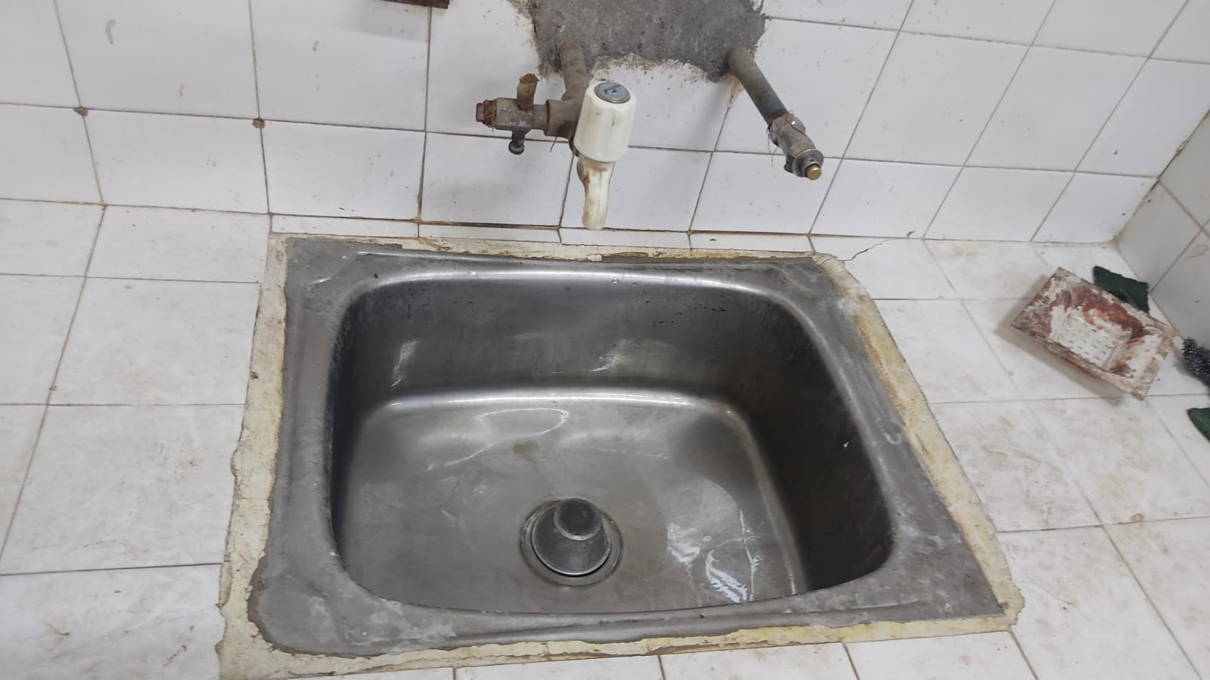

Day 4:

* We made holes in the bottom of the cans to pass the appropriate the length of the motors out of the cans. Filing was done at the end for smoothness.
* Also, we proceeded with the cutting of the parts of the net with appropriate dimensions.
* We also made the frame of the net using Shielded Metal Arc Welding (SMAW) to join MS rods.

Day 5:

* We got our 3D model printed in CNC workshop. Each propeller took 1 hour 14 minutes for getting ready.
* Apart from mechanical work, we also wrote the code for the Arduino and started our work to complete the circuit.



Day 6:

* We joined the net to the frame using stiff iron wires. It had started to get a proper shape.
* Side by side, we also worked upon rectifying the mistakes in the code of the circuit.
* Few people also went to Chandini Chowk to fetch the L298N Motor Driver.
* Rest people made holes in the front of the boat for the attachment of the net in the Machining workshop.
* Then we cut the nuts to the appropriate length, filed the end to give it a proper curve with a semi-circular file and finally joined the net and the boat.
* And at the end, we glued the propeller and the motor together using Fevikwik.

Day 7:

* We reworked with the code and circuit and finally, the propellers had started spinning though very slowly and stopping too quickly.
* After working for hours, we found out that we required individual batteries for Arduino and motor driver. Until this, we were using 9V batteries, which were getting drained within ten seconds.

Day 8:

* We decided to fetch a heavy battery which could power the motors more efficiently and for longer duration. So, few people again went to the electrical to get it.
* By that time, the others attached smaller bottles under the net to ensure that it floats.
* We also sealed all the openings and tiny holes with M-Seal to prevent any water leakage.

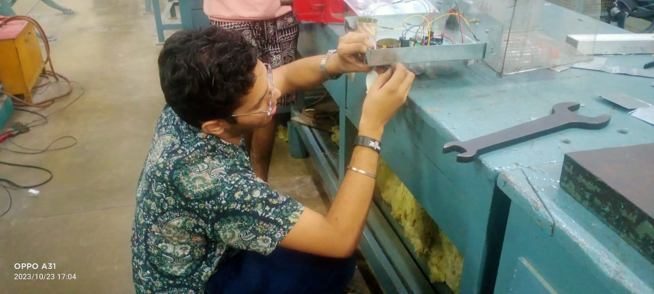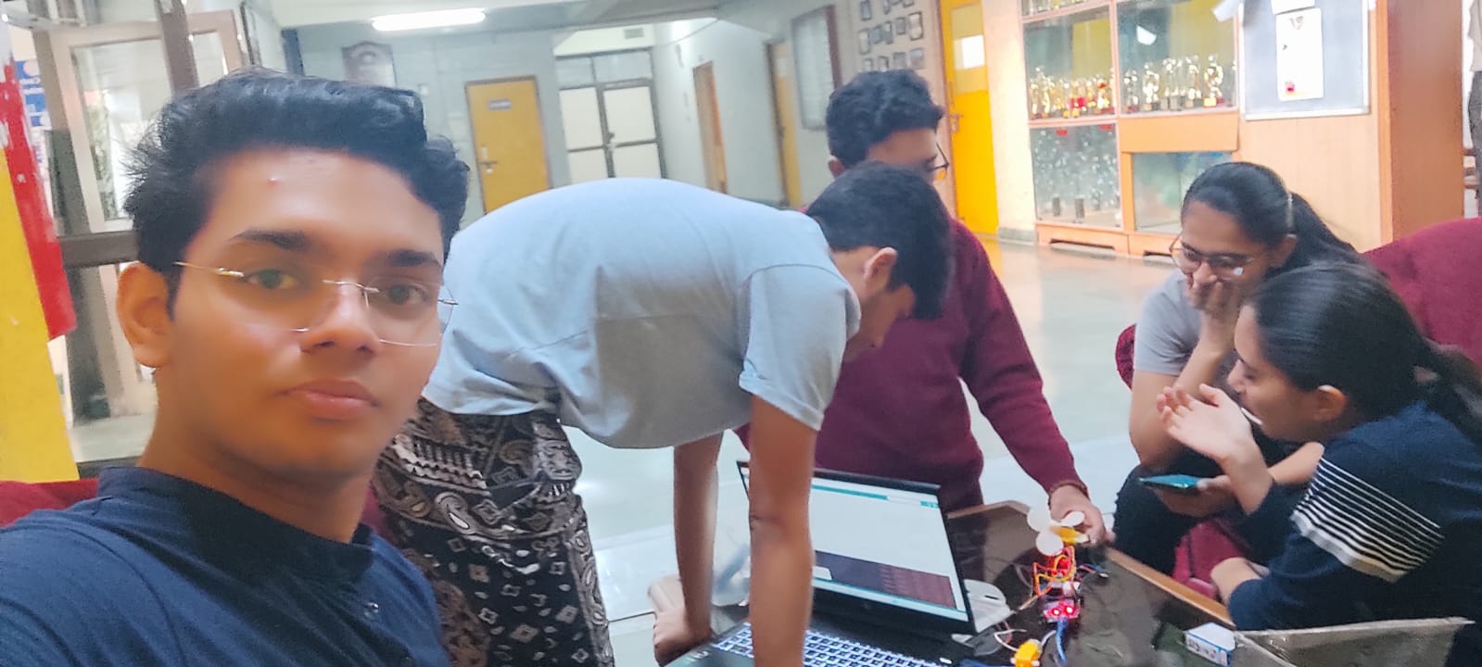

Day 9:

* We attached the heavier battery to the motor driver, and everything was in its best position.
* Then we went to the Swimming Pool and slowly lowered the boat into the water and ran it using our phone.
* It worked and we had finally accomplished our goal and completed the project.

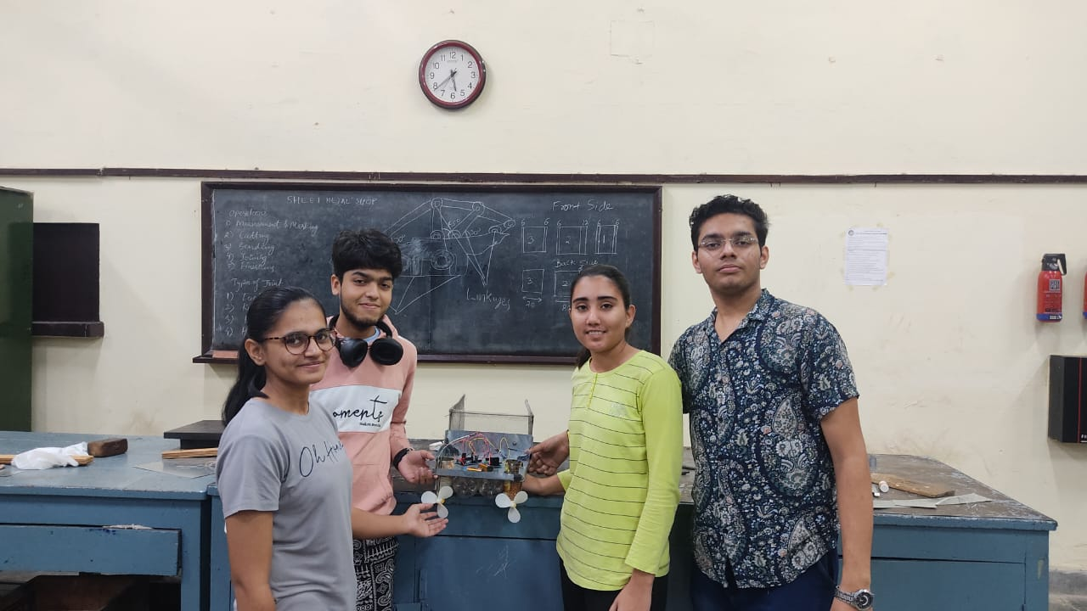

Problems Faced

1. Initially, we were going very smoothly with our project, like first two days were quite easy to go through, but we were completely unaware of the fact that a bounty of problems was waiting for us ahead. First one being the accident which our project encountered as it fell from the rickshaw by one of the teammates, deforming it to quite a lot, but we were also no less, we confidently hammered all the bends and replaced one of the can which had also got deformed during the accident.
2. After the dry test, we also found out the problem that the boat without net was bending in the front, so we understood that we will have to attach some extra bottles under the net to account for this problem.
3. The cutting of the net was not so easy as it seemed it would be as it had several sharp wires along its edges.
4. The arc welding of the MS rods was also not that easy because the rods were quite thin, so they would easily melt if the electrode was kept for a bit longer. Also, it took us quite a few attempts to make even one joint.
5. Joining the net to the frame also acted as a mild obstacle which took us time to complete but we eventually somehow managed to give them proper shape.
6. The motor driver which we had initially ordered did not work as we expected it to work, so few teammates had to go to Chandini Chowk to fetch the appropriate motor driver, which was a challenge, as to find the right piece for our circuit.
7. When we got our propellers printed, then we realized that the hole in the center was not big enough to insert the rotatory part into it, so we enlarged the hole using the drill in machining workshop. Then only we were able to put them together using Fevikwik.
8. The code and circuit created a lot of mess and stood like a hurdle till the end. Initially, the motor driver did not work. When it was fixed, then the code and the app which we were initially using did not work as it was supposed to do. After fixing all this stuff, writing new code, finding new app via which we could communicate with the Bluetooth module, we encountered the problem of the power consumption by the motors and the motor driver, which caused us to go and bring more heavy battery to support our mechanism.
9. During the test, we observed that the base of the net was not getting submerged under the water completely, so we were forced to add some weight into the bottles, which could lower the base of the net.
10. Lastly, we did not think that water might damage the electrical if anyhow it entered into the boat, so cut a plastic plate so as to cover the electrical and prevent them from getting wet.

Conclusion

We made our project from scrap, and we learned a variety of things-

Technical Skills: Engaging in welding, filing, and cutting activities allows team members to develop and enhance their mechanical skills. We gained practical experience in using tools and equipment, understanding welding techniques, and mastering cutting and filing techniques.

Safety Precautions: Working with welding and cutting equipment involves inherent risks. Through this project, team members learn about the importance of safety precautions, such as wearing appropriate protective gear, handling tools properly, and maintaining a clean and organized work environment.

Collaboration and Communication: Teamwork is a fundamental aspect of any project, especially one involving multiple processes and tasks. Members learn to collaborate effectively, delegate responsibilities, and communicate with one another to achieve project objectives.

Project Planning and Organization: Completing a mechanical project requires careful planning and organization. Team members learn to create project timelines, set realistic goals, allocate resources effectively, and manage their time efficiently. They develop skills in prioritizing tasks, coordinating efforts, and adapting to unexpected challenges that may arise during the project.

Problem-solving and Adaptability: Mechanical projects often present unforeseen issues or complications that require problem-solving skills. Team members learn to think critically, identify problems, and explore creative solutions. They develop adaptability by adjusting their approach, modifying techniques, and finding alternative methods to overcome obstacles encountered during the project.

Cost Estimation

1. Arduino Uno R3 – Rs. 480/-
2. L298N Motor Driver – Rs. 110/-
3. Pack of Jumper Wires – Rs. 100/-
4. LIPO 11.1 V Rechargeable Battery – Rs. 950/-
5. 9V Battery – Rs. 40/-
6. 2 DC Motors – Rs. 210/-
7. Wire Mesh – Rs. 120/-
8. M-Seal – Rs. 81/-
9. Fevikwik – Rs. 10/-

Total Cost: Rs.2101/-

Individual Contribution

Aditya Jaiswal (2023ES10512) (Team Leader): Shear Cutting, Punching, Filing, Welding, Bending, Rod Cutting, Joining, Circuit Making, Drilling, Ideation, Report Making

Jayesh Narayanan (2023EE11048): Punching, Filing, Ideation, Circuit Making, Coding.

Shreya Yadav (2023EE11063): Ideation, Welding, Net Making, Dimensioning, Report Making

Sarthak Garg (2023ES11065): Net Cutting, Procurement of Materials

Kalyani Charan (2023ME10452): Research, Procurement of Material, Strip Cutting, Net Frame, Report Making

Raghav Narang (2023ME11165): Procurement of Mesh, Cutting and Designing of Mesh, Connecting Mesh to Frame, Dimensioning

Yuvraj Singh Sivia (2023ME20112): Procurement of Material, Net Making, Weight Calculation

Tushar Saini (2023ME20810): Research, Filing, Shear Cutting, Procurement of Fevikwik

Rupavath Mahesh Babu (2023MS10224): Paperwork, Cutting and Dimensioning of metal sheet, Net Making, Filing

Ayush Lekurwale (2023MT10087): Ideation, Material Procurement, Chiseling, Sealing, Report Making

Aaditya Mehar (2023MT10703): Coding, Circuit Testing, Propeller Design and Printing,

Priti (2023PH10259): Strip Making, Sealing, Frame, Circuit Testing, Report Making

Anumit Ghosh (2023PH10920): Coding, Circuit Making and Testing, Dimensioning, Designing of the Model